MRI Philosophies and Sayings

Introduction

These sayings, stories and observations were collected over many decades of research, teaching and travel. Some are quotations, some are anecdotes, some are lessons learned through success and failure, and others are simply reflections on life. Together they provide a glimpse into the experiences and philosophy of a scientist whose career has been closely intertwined with the development of MRI.

I. MRI Quotes & Stories (50 items)

1. “In MRI, we listen to the music your body plays.” EMH.
2. “You can develop many imaging concepts by entering the k-space playground.” EMH.
3. “The CROWNing moment for STAGE occurred in the Kingdom of Tissue Properties.” This refers to the fact that R1 and R2* can be related to the inverse of the spin density. CROWN stands for Constrained Reconstruction Of White Noise. EMH.
4. “Most radiologists, and maybe even many physicists as well, don’t realize that every time they look at an MR image, they are visualizing the result of a quantum mechanical effect.” EMH.
5. Prof. Haacke, upon receiving the Gold Medal from the ISMRM, said that MRI is “Semper Incitare” — “Always exciting” or “There is never a dull moment in the life of an MR scientist.”
6. Richard Ernst said this eloquently in his 1991 Nobel speech: “I’m not aware of any other field of science outside of magnetic resonance that offers so much freedom and opportunity for a creative mind to invent and explore new experimental schemes that can be fruitfully applied in a variety of disciplines.”
7. “Most new insights come only after a super abundant accumulation of facts have removed the blindness which prevented us from seeing what later comes to be regarded as the obvious.” Quote from I. I. Rabi.
8. “Every creative act is the result of a sudden cessation of stupidity.” Quote from Edwin Land.
9. “MRI is a symbiosis of many fields from physics, chemistry, computer science, engineering, mathematics to radiology, neurology, neurosurgery and other medical disciplines.” EMH.
10. “MRI is so powerful and diverse in its capabilities that it has become the umbrella of all imaging modalities.” EMH.
11. “With MRI we have the ability to massage the spins to accomplish even mathematical processes.” EMH. While Erwin Hahn felt: “There is nothing that nuclear spins won’t do for you if you treat them as human beings.”
12. Beethoven wrote some amazing music. “I consider CROWN to be my opus magnum, my 6th symphony, while STAGE is my 5th symphony.” And if that analogy is continued, then SPIRIT (Signal Processing In Rapid Imaging Technology) is my piano concerto number 5. EMH.
13. “Radiology is no longer just about better diagnosis, but with the advances in imaging biomarkers and novel techniques to study the pathophysiology, it is also about studying the etiology of disease. That is where my drive and enthusiasm come from in developing new sequences and doing research.” EMH.
14. “The day is coming when rather than having to decide on different sequences in a given imaging protocol, that the multi-contrast methods like STAGE will be run by everyone and the Radiologist will only need to decide which images need to be reviewed for this particular patient.”
15. It is surprising how many of the original people in MRI are still active today. MRI seems to be good for physicists’ health; maybe because it is so interesting and so dynamic. I like to tell the students that I am as excited today about MRI as I was when I first started forty years ago! EMH.
16. Today the new scanners have 200mT/m, 64 channel coils, powerful computers and artificial intelligence (AI) for improved SNR and super-resolution. What will this next generation of the k-space playground include? I predict visualizing the layers of the gray matter using 100–200 micron resolution.
17. Interesting acronyms: SWIM, STAGE, SPIRIT, CROWN, COMPARE, RAZOR, CORE, BART and BERT the twins, and perhaps the cutest of them all, MARSUPIAL. MRI is filled with many such acronyms and I am to blame for a number of them!
18. Hybrid echo planar imaging — musical gradients at Picker International: This was perhaps also motivated by something that I did at Picker International when developing hybrid echo planar imaging. The oscillating gradients I used were almost musical so I had the gradients designed to play “Close Encounters of the Third Kind” whenever it was my turn to use the magnet. We worked in a very long modern newly built structure that had metal frames and roofing and apparently that sound traveled all the way from one end of the building to the other right to the President’s office. Little did I know that everyone was saying, “Oh it’s Haacke’s turn on the magnet again!” Even the President, until one day he called me to his office and said: “Well Mark that’s an interesting way to start your work, but the sound is a little disruptive as it’s heard throughout the entire building.” Many years later people at the ISMRM rediscovered this ability to make music with MRI, but I believe I was the first to implement it.
19. Shark bites: When it comes to the effects of field inhomogeneities, I often call the loss of signal around the air/tissue interface by the lower brain and pituitary gland “shark bites”. This nomenclature came from one time I was scanned on a 1T scanner at University Hospitals of Cleveland. I had developed a fast gradient echo imaging approach for body imaging, likely one of the very first for rapid breath-hold imaging. When I came out of the scanner, the student said “Dr. Haacke, you have something wrong at the edge of your body, there is no signal there!” I thought about this and looked at what I was wearing and evidently in the top border of my underpants there was some iron in the cloth material. It was at that point that I jokingly said: “Don’t worry it’s just a little shark bite caused by the iron filings perhaps in my undershorts.” EMH.
20. The alien artifact: When you scan a woman with mascara even at low field it causes what I refer to as “The alien artifact.” This is because the perhaps few-micron thin layer of iron in the mascara has such a high susceptibility that a 10-micron layer with a susceptibility of 10,000 ppm becomes like a 1 cm layer of a substance with a 1 ppm susceptibility, enough to dramatically disrupt the local field.
21. The Gollum quiz: “What can be seen but cannot see? What can be read but is untouchable? What has i’s but has no eyes? What can reveal secrets hidden in water?” MRIs (MR “eyes”). EMH. This is similar to the quiz from Gollum to Bilbo Baggins in Lord of the Rings: “This thing all things devours; Birds, beasts, trees and flowers; Gnaws iron, bites steel; Grinds hard stones to meal; Slays kings, ruins town; And beats mountains down.” The answer is time.
22. SWI and the clinicians: SWI took a long time to take off. But once it was available as a product by Siemens it entered into the clinical realm. Then there were more and more papers on its clinical applications, far more than I had ever imagined. That motivated me to say: “Put something new into the hands of the clinicians and they will find many more applications for it.” Quote by EMH.
23. Walter Maerzendorfer from Siemens, after attending a high field meeting about 20 years ago, said: “The new 7T SWI images are just exquisite with incredible details down to the smallest of veins. But what’s it good for?” Well more than 2000 papers on SWI since that time, I guess the radiologists finally figured out what it was good for!
24. There is an old Wizard of Id cartoon where he shows the king a new compact nuclear device and the king says, “What’s it good for?” The wizard answers, nothing, but it’s worth a fortune in grants.
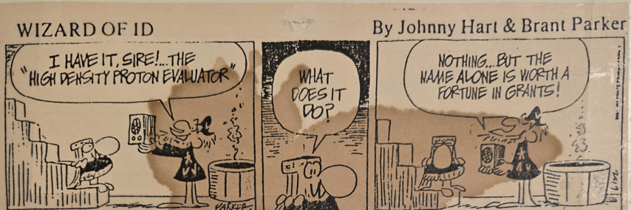

25. Strange titles: Once I was to talk on MRA and they verbally asked for the title which I called something like “Progress in MR Angiography” but the final title that appeared in that conference was: “Progress in MR and Geography”; how funny. Another recent talk in Changsha was also from a verbal discussion where I said I would talk about STAGE and possibly add something else unique related to iron content. The talk title formally appeared as: “Advances in STAGE Imaging or something else.”
26. Reviewing the past literature is like time traveling down a helix of DNA of stored historical ideas. Many times you will find that the ideas were already there but the technology was not yet able to take advantage of them. That is sometimes the danger of being too precocious! EMH.
27. I recall in the late 1980s showing beautiful 512 MR angiograms. Only today are people beginning to match what I did. Someone said after seeing my presentation: “Oh it’s impossible to replicate what Dr. Haacke is doing, it can only be done at his site and on a Siemens scanner.” Well, that’s a nice comment on how precocious and insightful our research was in those early days.
28. In 1992/1993 I took a sabbatical with my family to Erlangen to work with Siemens for a year. During that time, Tom Miller was there and I convinced him that 3T was the optimal field strength, the next jump in fields from 1.5T. This was based on a calculation including SNR, T1 increases with field strength and the reduction of signal from T2 becoming lower and lower at high fields. And, indeed, 3T has become quite popular. Today, even 5T and 7T are approved for clinical use. And there are 9.4T, 11.7T scanners too and maybe one day in Holland a 14T whole body scanner for imaging humans!
29. In a very recent paper on CROWN I quoted Mencius, Gong Sun Chou II: “Tian shi, di li, ren he” meaning “All conditions are favorable, having the right time, the right place and the right people.”
30. The MS scan study: We once did a research project for studying multiple sclerosis using almost every method under the sun. Our conclusions were that only a very few such as water content and susceptibility using STAGE, FLAIR and DWI revealed critical information. Using only these three takes only about 10 minutes of scan time. After we imaged a subject using just these three methods, we brought him out to see his results, then he said, okay you can put me back in now. And I responded we are done imaging. He looked a little disconcerted and said: “What? They usually scan me for an hour. Put me back in the magnet, I didn’t get my money’s worth!” EMH.
31. One day JJ Daniel Wang sent me a message saying thank you. Evidently his father had had a stroke and he was scanned using SWI. He called me to thank me for having invented SWI.
32. My sister-in-law needed a scan and was going to have to wait months in Canada. So, I had them come to Cleveland. We scanned her and found two hemangioblastomas. She had von Hippel-Lindau disease. We sent her back to Toronto, and within a week they operated on her. That was nearly 40 years ago. Many people in her family died in their 30s because there was no imaging and no surgical cure. She is still alive today thanks to modern medicine.
33. I am not a great artist, I can barely draw a circle, but I have created some great art through magnetic resonance imaging. One of the loveliest of these is the MICRO imaging Christmas movie that Sagar Buch put together with Beatrice Ghitti.
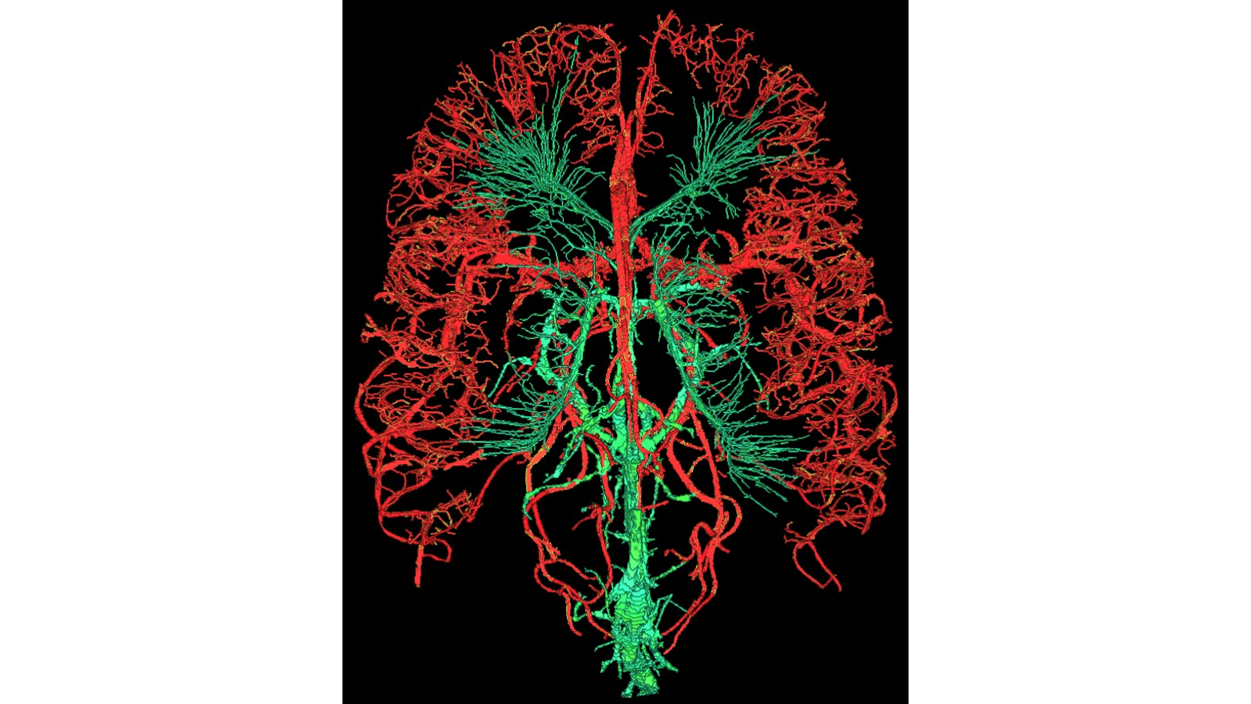

34. In early MRI there was a great deal of interest in MR spectroscopy and some very famous people like Ian Young and Paul Bottomley were working in this direction. I had to make a choice which way to go and so I chose imaging. This brings to mind the famous stanza from Robert Frost’s The Road Not Taken: “Two roads diverged in a yellow wood / And I took the one less traveled by / Because it was grassy and wanted wear / And that has made all of the difference.”
35. Sometimes I have to make things very simple when it comes to describing how spins behave and dephase and rephase over time after certain rf pulses. I have come to call this: “Finger physics.”
36. Through the looking glass (1): In another paper, I used the quote: “Through the looking glass.” Sometimes one has to peer beyond the borders of current knowledge, beyond the rules, into the impossible. And sometimes, just sometimes, it is possible to overcome what were originally thought of as impossible barriers and come up with a completely novel solution, such as the new method we developed for super-resolution.
37. One summer around 1987 we had a lovely two-week break at the cottage. While sitting in my grandmother’s rocking chair, I was hit with an “Aha” — an epiphany that one didn’t need to use Fourier basis functions, but one could use polynomials to fit the sharp edges or blurred edges between tissues. This led to super-resolution reconstruction.
38. Super-resolution and Liang Zhi-Pei: There is a cute story about this. Once a student came to me looking for a project in MRI. I told him how I thought we could solve the super-resolution problem by creating a new basis function and avoiding all Fourier limitations such as Gibbs ringing. He became quite flustered and ran away saying: “This is impossible, it is not what I learned in school.” A week later he came back asking if I could tell him more. Later, we won an award for the paper that came out of this idea. His name was Liang Zhi-Pei who became very well known and even became a post-doc for Paul Lauterbur. The lesson: don’t necessarily believe everything you have been taught or read. Question the boundaries of what we know.
39. Through the looking glass (2) — Lewis Carroll: In another paper I quoted Lewis Carroll regarding Alice in Wonderland, the girl who had the magic mirror and the imagination to see what was on the other side of it. The alternate title for this book was: “Through the Looking Glass.” This is what one has to do to be creative, to look past what the field believes to be cast in stone and impossible to solve, just like CORE imaging chose to use a new basis function to remove Gibbs ringing, provide enhanced SNR and super-resolution.
40. Using the picture from Rembrandt, “The Anatomy Lesson of Dr. Nicolaës Tulp”, we can say: “In the old days we used to cut people from the outside in, today we evaluate the human body from the inside out.” EMH.
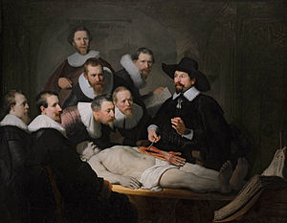
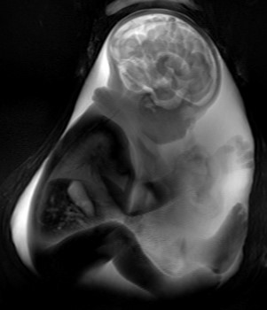

41. It pays to look back in time, sometimes even hundreds of years. In my paper on super-resolution, I referenced the work of de Prony who had developed a method to solve the roots of polynomial equations. This work was published in 1792. When the reviewer first read our paper, he wrote back: “Don’t you mean 1972?”
42. In another work on least squares analysis, I realized that if there are errors in both variables one should use a moment of inertia analysis to solve the problem. In carefully researching the literature I found that the famous English statistician Karl Pearson had already solved this, and a number of other people rediscovered this after him, including me 100 years later.
43. Hardships can challenge you in a positive way for your research. After having developed STAGE and formed the company SpinTech as Chief Science Officer and major shareholder, there was a hostile takeover by investors. Due to their lack of interest in research and expanding into China, I chose to resign. Since I still wanted to pursue qMRI and STAGE data acquisition this forced me to reinvent the entire processing, which, amazingly I did over a two year time period; it’s called SPIRIT.
44. There are a few times in my life when I have had a lot of ideas but the environment was very restrictive, including the most recent situation at SpinTech. There are two cute expressions alluding to the same thing: “I feel like an eagle chained to the ground.” Or “It’s hard to soar like an eagle when you are surrounded by turkeys!” EMH.
45. We used to study motion artifacts or what we called ghosting artifacts from motion. On one paper dealing with this issue I quoted Goethe’s Sorcerer’s Apprentice: “Master, Great is my distress today, the ghosts that I have summoned just will not go away.” I eventually developed the basic concept called flow compensation by adding a third gradient lobe to the readout to refocus spins from constant velocity moving blood.
46. When it comes to publishing and insight one often has to be very determined and confident. When I invented the concept of flow compensation, I wrote a paper to Radiology. They dismissed it as just another paper about motion, how short sighted and wrong they were. I then submitted it to AJNR and Thomas Berk the editor at that time not only reviewed the paper but accepted it in two weeks; the fastest I ever had a paper accepted. Today it is the basis for MR angiography. The lesson is of course not to give up, especially if you feel or know that this direction is tantamount to a paradigm shift in the field. Today we are trying to convince the Radiology field to adopt SPIRIT. Once again I have submitted a paper to Radiology on the use of short TE SWI for faster and clinically diagnostically equivalent SWI imaging. Once again they have editorially rejected it. An unfortunate lack of insight.
47. Although many times bad results are because of operator error or poor design, every once in a while what can be an enigma or confounding issue is when no matter what you do the problem won’t go away. Ahhhh, then it turns out to be the fault of the magnet, a malfunction in the gradients or the rf system. Then it wasn’t your fault after all, thank heavens!
48. Facts are often buried by the sands of time. Quote by EMH. When it comes to remembering how the ISMRM merger concept began and who implemented it, surprisingly few people know. Already 30 years of water under the bridge, but it is an interesting story, told elsewhere about a young man with the belief that there should be one society and all societies around the globe should be shifted apart from each other in time with respect to their annual meetings including the ECR and the RSNA.
49. One individual said that my energy level is driven by an internal nuclear power forged from the intense interest in science and discovery. Quote from Wu Bo.
50. This poem is about the four most impactful things that I have seen and experienced in my life.
I’ve seen the Grand Canyon and two billion years,
I’ve seen the sky turn pink and all of God’s tears.
I’ve seen the Aurora Borealis light up the night sky, and
I’ve lived an exciting life of research in the field of MRI. EMH.

II. Student & Research Stories (39 items)

1. “Read, read, read until you know every detail of your own project. Learn the topic so well, you could give a talk on it to your fellow students.” EMH.
2. “There are a few sentences in the Green Bible that took us an hour to agree upon.” No wonder it took 7 years to finish the book, 28 man years for nearly 1000 pages. EMH.
3. “There are images in the Green Bible that represent entire MS or PhD theses.” EMH.
4. People say when I start talking about MRI my eyes light up and I am full of energy. Once a student came up to me after my lecture and said that she thought my presentation most enthusiastic. This same student, now a physics high school teacher, said that this gave me an iridescence. Quote from Jiang Caihong. And she referred to the quote: “Every once in a while you meet someone who is iridescent, and when you do, nothing will ever compare.” [from the movie Flipped] and said that is how she felt about my attitude toward doing research in MRI.
5. A senior engineer once approached me after a talk and said: “Can you teach me how to give such entertaining talks?” And a long-time colleague once said: “I have heard your talk many times and never yet fallen asleep!”
6. Winston’s Star: Winston’s star, based off the ideas of MIT AI scientist Patrick Winston, is a symbol representing a list of “S” words to help make your work and any talk you might give memorable. Symbol — an icon of your work, what you will become known for; Slogan — a catch-all phrase of your ideas; Surprise — a result people hadn’t expected; Salient — the key insight or idea behind your work; and Story — get the audience to relax and perhaps more attentive by telling some stories. However, I would add more concepts starting with S: keep the material in each slide “Short”. And perhaps another S, “Simple”. Create a simple analogy if viable to get people to understand the concepts. And yet another one, “Sexy”. Have a 3D or powerful visual slide that represents your idea and wows the audience.
7. Ramesh Venkatesan: Ramesh Venkatesan was both my MS and then PhD student. In his MS project, we had looked at the sharing of k-space to create MIP MRA images at any angle without interpolation artifacts. About a year after he started his PhD, he came into my office and meekly said, “Prof. Haacke, can I admit something to you?” He said: “I wanted to tell you that I finally understand what I did in my thesis.” Oh my, what an honest young man. This raises a very important point. You can use mathematics but that doesn’t mean you understand what you are doing or the meaning behind it or the importance of it. That is, sometimes you are just a calculator not a scientist. The scientist uses the physics and mathematics together to understand the physical meaning behind what he is doing.
8. The take home message from that story is practice. “It can take years of reading and practicing a given technique to fully digest it and appreciate it in order to take yourself to the next level of understanding that eventually leads to further breakthroughs.” Quote by EMH.
9. Many people warned me about giving away too much information in my talks. When I gave talks about certain new ideas, I would reveal everything, all our tricks and ideas. Many faculty would say to me, “Why do you risk telling people everything?” I would answer, “Don’t worry, they are years behind; even if I tell them everything, it will take them a long time to both implement it and understand it.” EMH.
10. Someone once asked me if I were a Radiologist. No I would answer, but then I would follow that with “However, I have been meeting with Radiologists throughout my MRI career and over time have absorbed a lot of their knowledge by osmosis.” EMH.

11. In the same vein, the work we do is not for us to put in a library and say look here’s my work. Our goal is to disseminate these ideas, teach the next generation of young physicists, and add knowledge to our field. When a student says to me, “Oh look, someone else is using our method!” I just smile and say: “What better compliment to our work than someone picking up the baton and carrying it further in the race for practical implementation.”
12. Once an up and coming young Chinese researcher was telling me about certain projects and I smiled and said “Oh yes we’ve done that and we’ve done that too” and, finally, he mentioned a project we hadn’t done and I said, “Now that’s a very good idea.” And he laughed and said: “Well thanks for leaving me something to do!”
13. One of my PhD students, Gerald Lenz, wrote me a lovely card after he graduated and it started off with: “Dear Mister, Father, Doktor, Haacke”. Although this is very formal, the father part really caught my eye because as Professors we are responsible not just for the student’s training and education but for their ethical behavior and many times as a guide for them as a surrogate parent. Only recently a doctor from Shanghai wrote me: “Thank you Jiao Shou, you help us not only in our studies and research but also in our mental health.”
14. The absentminded Professor: Another time, the absent-minded Professor Haacke was preparing for an 8am lecture on physics to a class of about 200 students. I liked to go 100% prepared to give the lecture without using notes or a book. One day I was still preparing around 8am and I realized I was late. I had long hair and would often comb my hair first before I went upstairs. So, I dashed away and started to run up 3 levels of stairs. On the way up Prof. Keith Robinson stopped me and said: “Is that a Canadian custom?” What’s that I asked? “Wearing a comb in the middle of your hair!” Oh my, thank heavens he caught me or my students would have had a great laugh.
15. Dr. Jekyll and Mr. Hyde: In the old days people used to say this about working with me: “Prof. Haacke takes no prisoners.” That is, expect to work hard and learn well if you work for me. Maybe that’s why Todd Parrish gave me a birthday present once of a T-shirt that had a picture of the good, kind professor teaching (Dr. Jekyll) and the crazy mad Professor on the back (Mr. Hyde).
16. Talk softly and carry a sharp pencil: There is an expression in English about keeping things under control, “Talk softly but carry a big stick.” In my case, academically, they will tell you that Prof. is a gentle person and always prepared to do calculations, so this expression gets modified in their eyes: “Talk softly and carry a sharp pencil.”
17. Once I was moderating a weekly meeting at Ruijin with a guest speaker. Although his slides were in English, the class preferred for him to speak in Chinese. At the end of the lecture, they all kept speaking Chinese and then they broke out laughing. And I said to the group: “Okay, okay, you can tell the jokes in Chinese, but you have to laugh and smile in English!” There was a bit of a delay, and then they broke out smiling in English.
18. Teaching statistics: I used a group approach of 5 or 6 students a table where each group tackled one of the questions for the day. I would sit with each group for about 10 minutes answering questions and then move to the next one. At the end, one student from each group would go to the board and present the group’s solutions. This method of collective learning led the average in my class to be 82 — a full 10 points higher than the other 260 students taught by other Professors. The key is to always question the basics of what we are learning. Once people have learned the fundamentals, you will never forget them, it’s just like riding a bike. EMH.
19. Today, project-based learning is recognized as a key learning tool to inquire, question, work, think, and rethink how to solve real-life problems. Good/great teachers introduce new ways of thinking. Understanding how best to tackle or think about a problem can help navigate not just a course but also navigate throughout our lifetimes.
20. Similarly, teaching students in groups of 5 or 6 and letting them learn by discussing the material and their understanding from their perspective can dramatically enhance their learning skills. EMH.
21. The failing student: During my teaching of first-year physics, I had a student who was doing very poorly. After the end of the semester, he came to my office and asked me if I would raise his grade from 48 to 50 so he could pass. I had a long talk with him and suggested the best thing he could do was to start again and just take 4 classes instead of 5 so he could really focus. Almost a year later, he came back to see me, and he said: “Prof. Haacke, I was pretty disappointed when you didn’t raise my grade, but my parents agreed, and I heeded your advice and took only 4 courses. And I am here today to thank you because this year I got straight As.” Sometimes if we recognize we bit off more than we can chew, we can cut back and do a lot better by focusing where it counts the most.
22. It’s hard to write a perfect paper. Often, as I read a book I will find a typographical or other error. This is equally true for scientific papers. The worst of course is if there is a mistake in an equation, that’s embarrassing. But I used to tell my students, give me any paper, and I will likely find at least one error in it. Life is tough, perfection is even more difficult.
23. One of my best students once made the following remark: “If Prof. Haacke had enough students he could accomplish anything.” Now how can we get “enough” students to work with me? Perhaps this idea of having a monthly lecture called “An Hour With Professor Haacke” might help accomplish that. It would be ideal to create a WeChat program called: “An Hour with Prof. Haacke.”
24. When I received the Gold Medal in Kyoto it was for my development of many new methods and for my educational efforts in writing the famous “Green Bible”. Michael Mosely was the President then in 2004 and he started showing pictures of me from a baby, growing up, to graduating with my PhD. For the last one he smiled and said: “At one point Mark was considering being a movie star, but luckily he chose physics as his career instead.”
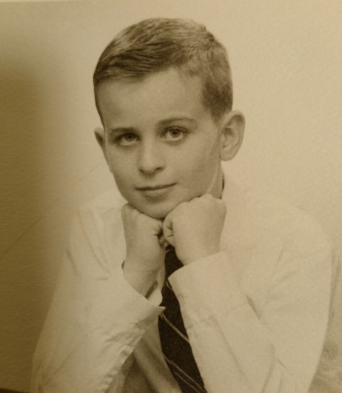
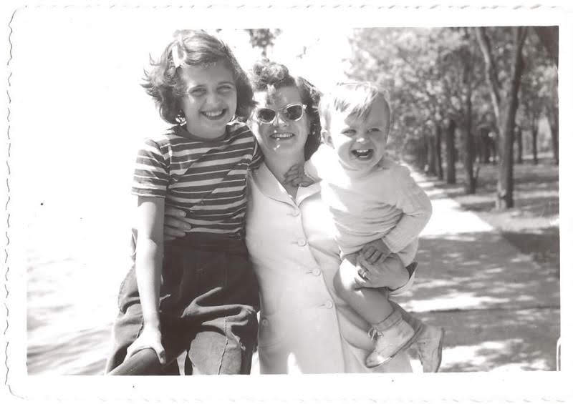
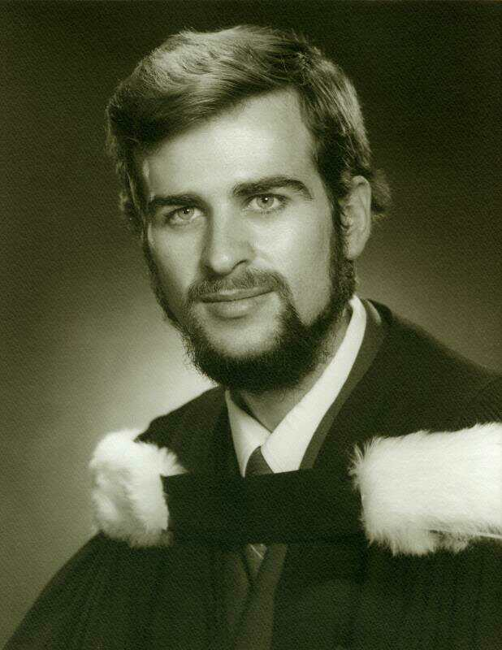

25. When a student or post-doc or even junior faculty got a paper published, I always liked to shake their hand as a form of congratulations. This always makes people feel good about themselves and their accomplishments.
26. Related to this was a recent ruling by Wayne State University that everyone had to be careful how they interact with people, particularly students and women. The next day in my office I had a Coke on my desk, and 3 or 4 students in my office, one of them a woman. Well, I became overly cautious, and I wouldn’t even look up at her when I reached for my Coke and eventually she said: “Prof. Haacke why aren’t you looking over here?” And I told her because according to these new rules I have to be careful how I look at you or appear excited by our research. She laughed and said don’t worry. Being able to make someone feel good about their accomplishments is important.

27. The happy camper: Once I took a trip to give a talk in Atlanta and met the head of the animal facility there. When I asked one Chinese student his interest, he responded: “I am interested in happy campers!” Oh really I asked, where do you do that in Atlanta? He looked at me confused. Eventually I said: “I assume you mean hippocampus!” Ah, language is a difficult thing to handle, especially a foreign language.
28. On another occasion, there was a contest at the ISMRM to view the past Presidents’ 3D volume rendered movies acquired using 3D gradient echo images. The challenge was to tell from the MRI data who was who? Can you guess which one is me? The hint even as a baby — always smiling.
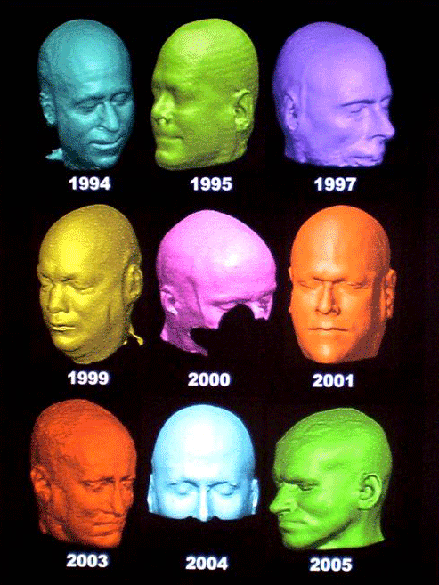

29. Expert witness: One time I was being deposed by lawyers in a case where I was an expert witness, it was a grueling 8 hours. They would ask questions so whatever answer you gave them they got what they wanted. But I constantly avoided giving them yes or no answers. Still, they pushed me and so finally I said to one of the female lawyers who was wearing a blue dress: “Is your dress black or white, give me a yes or no answer!” She smiled and withdrew her question. In the end the judge asked me for my summary, and the final decision fell on our side; the university won its case.
30. Coincidences: There have been some fascinating coincidences over the years. Once, I was talking to Rachel my administrator about Prof. Paul Swerdlow. I said, you know it has been a long time since Paul talked with us. All of a sudden, the phone rang and sure enough it was Paul on the line. A similar situation occurred with another Professor, but this time instead of a phone call, he physically appeared at the front door. Something similar happened in Singapore in 2024 where I met in the oddest places Prof. Yang Qing from Hershey, Pennsylvania. After the third meeting I told him it must be fate. The final lovely coincidence was meeting an old friend John Gore who I had planned to ask to meet with me to discuss some new publishing ideas, specifically a white paper on establishing imaging centers. As it turns out, on my way out of the meeting, heading toward the down escalator, who is there waiting for me but John Gore.
31. Recently at one of my presentations one of the MRI researchers said: “Listening to Dr. Haacke’s lectures is worth reading 10 years of papers on the topic.”
32. An idea or project you worked on before may not come to fruition at the time of invention for a variety of reasons — maybe it was too precocious, or there was no time or money to follow through — but that project may one day still find its day, so keep it. Quote by EMH.
33. Along these lines, your past life constantly interacts with your current and future life, so don’t view a past project as history; view it as something that you created and so it remains part of your bank of ideas, something that will always be there and accessible to you. Quote by EMH.
34. Coffee in the microwave: Often in the winter at Ferry Street, where we housed the MRI Institute, I would have coffee. In the winter I often used it to warm my hands more than drinking it. I would often get sidetracked talking with students and then look around asking: “Where is my coffee?” Almost invariably it was in the microwave being warmed up. I used to joke and say that when I died and they had a tombstone for me, there would be a little statue of me holding a coffee cup to catch the rain and constantly having fresh coffee for me.
35. It is always a challenge to find projects for students. However, many times when we have been very busy with a variety of projects, there are great opportunities for students to get involved in a project the minute they walk in the door. One student once said: “Professor Haacke needs an entire class of students to do the work for him.”
36. On occasion I have had a few students from industry get involved in a project that inspired them to go back to do their PhD. These students ended up with a great advantage: the day they walked in the door, they knew the direction they wanted to pursue, and, in some cases, their first paper was already in hand even before formally starting their PhD!
37. The last week in China: Toward the end of each of my stays in China it always gets a little hectic because I want to make sure that everyone has a lot of momentum on their projects. Sometimes these days last from 7am to 11pm without a break except for lunch. Many times, we order lunch or dinner and sometimes I even make my famous tuna sandwiches for everyone. This last trip, one student spent 7 hours going over a first draft of their paper. And I told the students that one hour is worth one day of my time. As she walked out the door I said to her: “You have had a week of my time today!” Another student found out and said: “I want a week too!”
38. Take chances and meet people. At the SMRI meeting in San Antonio around 1984, I found myself exploring the convention center and heard some voices in a small conference room. I walked by and saw Gary Fullerton at the blackboard and discovered they were planning next year’s meeting. So, I decided to be a little bold and knocked on the door: “Excuse me, I hear you are planning the topics for next year’s annual meeting. I have some ideas, do you mind if I sit in on this meeting?” Gary was very welcoming and invited me to join in the discussion. After that, there was no looking back and I eventually ran one of these scientific meetings and became its president shortly thereafter. This is the type of interaction that I hope the ISMRM will continue to promote, welcoming young people to participate.
39. In 2004, I won the Gold Medal when the ISMRM was in Kyoto. I had always heard that the Kyoto Prize in mathematics and physics was often a prelude to getting a Nobel Prize. I had in my early days hoped that I would one day do something sufficiently noble in the world that such a prize would be possible. However, the joy of creating does not need a prize, it only needs your own self-satisfaction that you’ve done something good.
40. The Green bible was really my opus magnum. Just like it took the great artists years to complete their major works of painting and sculpting hundreds of years ago, the Green bible to took 7 years to complete and really represented the culmination of years of teaching MRI.

III. Life Philosophies (30 items)

1. “Asking questions is the sign of an inquisitive mind and opens the door to a better understanding of the topic and with it often brings new ideas and new knowledge.” EMH.
2. Zhuang Zi: “Those with knowledge should use it to nourish what they don’t know.”
3. The Chinese philosophers Mencius and Xunzi both encourage you to: “Live up to your potential.”
4. From Anatole Abragam’s book, “Reflections of a Physicist”: “When all is said and done, I am happy to be working in a field where, with hard work and a modicum of talent, one can hope to make a useful contribution.”
5. Some colleagues in China have referred to me as a “junzi”. A scholar with high moral character including virtue and integrity (which is what was said of me when I won the Silver Medal of the ISMRM) as well as benevolence and wisdom. This is from Kong Zi or Confucian philosophy.
6. “He lived more than one life, half here and half in China being in both places either physically or mentally.” Comment about EMH.
7. When I was a student at University, I was always known to: “Have a book in hand, a project in mind, never wasting a moment.” In those days I couldn’t gobble enough science. EMH.
8. “Team science through international collaboration can often solve problems an individual cannot because of the combined broad knowledge base and different ways of thinking that they bring to the table.” EMH.
9. “The more you read, the more you discuss, the more you practice, the more you teach, the more insight you will gain. Sometimes this insight will lead to inspiration, which can come when you least expect it, like waking up in the morning with the answer to yesterday’s question, or taking a long philosophical walk in a beautiful Suzhou garden.” EMH.
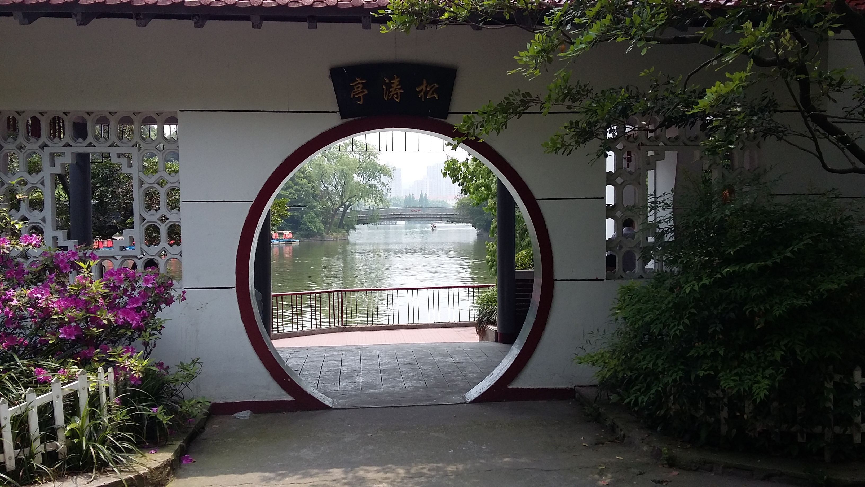
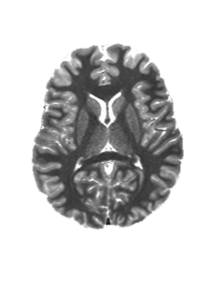

10. “Perfection is an enemy of progress.” It can take just a few minutes to have a great idea but to bring that idea to fruition can take a very long time, even years. So, the expression goes: it can take 20% of your time to develop the first 80% of a product and 80% of your time to develop the last 20%.
11. “Wealth is not in having great possessions but in having few wants.” Quote from Epicurus. Remember that the Epicurean philosophy taught that the world was made of indivisible atoms.
12. The Golden Rule applied: “Do unto others as you want them to do unto you.” When you treat people kindly you will in return be treated kindly. One such example happened when I was running out of money for the MRI Institute in St. Louis in the late 1990s. Then I got a phone call from Herb Meltzer, a Chairman of Psychiatry who I had helped with his imaging projects 10 years earlier expecting nothing in return. He called to discuss a project worth $100,000, a lot of money in those days, which basically saved my research company from going out of business. You never know how helping people may lead to good things later in your own life.
13. “As human beings, we need to interact with people; that’s how we live, learn and love. Without interaction there is no time and there is no life.” Quote by EMH.
14. “The forces of nature have brought us together. And in creating sentient beings new forces have been created; those that are created by communication are a totally different type of force, but they are indeed also a force of nature.” Quote by EMH.
15. What’s really amazing is the way things seem to fall together sometimes. This is because the more you read, the more you know, the more you think, the more you can integrate everything together into something new. There is a paper about this by William Shockley, the man who created the p-n junction theory from which sprung the transistor technology and for which he won the Nobel Prize.
16. My eldest son Bryon used to say: “Dad, you live in your own dream world.” He thought the world was not as nice and kind as I made it out to be. My answer to him was that you need to build your own world and surround yourself with people of the same philosophy and create an environment that fits your own character and beliefs. In the end, the entire world is, in fact, viewed from your own perspective, and it is, in part, what you make of it.
17. Someone once said to me that I have a lot of collaborators. And I answered: “Yes, indeed, I enjoy working with people, and the world is my playground.”
18. And there is an entire world of smart people out there waiting to make contributions. That is why I want to provide a set of unsolved problems and let the new generation step in and take over and use their skills and ingenuity to solve these problems.
19. My grandfather on my mother’s side (Herbert Davies) used to say: “A change from your everyday work is as good as taking a break from it, even if you are working hard on something else.” This translates into a research philosophy too. I often had my students work on 2 or 3 different projects every day, some rather fast to solve, so that something got accomplished every day. This way, one felt that they were making progress.
20. Well perhaps one of the most important changes is getting a vacation from work — letting yourself wind down and your mind clear, akin to getting a good sleep and waking up refreshed. And who knows what you might invent (see earlier about inventing super-resolution).
21. On the other hand, my grandmother on my mother’s side (Nellie Mae Wallbank) used to say: “Everyone should have (or deserves) a crazy half hour every day.”
22. Many people are stressed out when they have a big project to do. The more they accomplish and begin to complete the task is like turning a bottle of water into a jug of wine. At the end, with a sigh of accomplishment and satisfaction, they can sit back and enjoy the fruits of their labor and take a drink of that wine. EMH.
23. Why read history? Why write an autobiography? Denis Diderot wrote: “…that our descendants, by becoming more learned, may become more virtuous and happier, and that we do not die without having merited being part of the human race.” And I would add: “and by sharing our life’s experience with this and future generations of our family.”
24. Now imagine AI comes along and strips away all blue-collar and white-collar jobs. What then? No work, no motivation? Maybe not — maybe then we can focus on the talents of each individual. Each person could focus more on developing themselves rather than in competition academically. AI can assist creativity, but the deepest conceptual breakthroughs still appear to arise from human imagination and inspiration (written by an AI software!). My original comment was: AI is not creative. AI would likely never have dreamt of relativity or quantum mechanics, these are inspirational ideas. And whenever we create new concepts, they will generate more new rules, new capabilities, new possibilities and perhaps leading on and on to many discoveries we can’t even imagine today. EMH.
25. One morning on my way to Ruijin Hospital, I saw many people walking along the street heads bowed in early morning prayer to Buddha. And I thought, my they are all so religious, until I got a little closer and realized they were all praying to (or playing on) their phones! People need time to organize their thoughts and not overload their minds with a constant deluge of information. So, when I walk to work and again when I walk home, I use that time to think, enjoy the life around me, the singing birds, the landscape, the blue sky and white clouds, lan tian bai yun.
26. One thing I tried to instill in the students was the idea that it was okay to work hard, even do grunt work, or get scanned, or read lots of papers as part of research. I would do all of these myself to show them and I would say to them: “I wouldn’t ask you to do anything that I wouldn’t do myself.”
27. After a solid month of working every day, meetings, writing, creating new software and new ideas, today I woke up after 11 hours sleep. I feel weightless, like Atlas having just been rescued by Hercules, no more with the weight of the world on my shoulders. A day off, a reprieve before next week starts. And the light is at the end of the tunnel, for I am returning home to my loved ones in a few days.
28. Sometimes good friends must part and head their own ways. But thanks to the internet today, communication doesn’t have to end. As noted by one such colleague: “In the future, you can still have a conversation through our papers, our books and our photos.” Quote by YeYe.
29. I have been traveling to China now for nearly 40 years. If I had visited one new city a year, that would be 40 cities. Well as it turns out, I visited my 50th city this year in Guilin and Yangshuo. It was almost a week without a computer and phone.
30. I traveled to China many times over the last 40 years. And in the first few days, right around 2pm their time, I got hit by what I called “The Chinese Hammer” — a sudden feeling of exhaustion. This was, of course, the consequence of becoming acclimatized to the new time zone, as opposite as you can get with a 12-hour difference. It often took a week of slowly eking my way out of this and pushing the bedtime to 9pm.
31. When I was about ten years old, my father was using a beautiful Underwood typewriter in his office basement. It sat there on a large brown business desk inviting me to use it. My writing in those days was very bad and the teacher always had me rewrite my stories. So I thought, let me use this beautiful machine to type my story. After typing it, I left for a few minutes and it was on the desk beside the typewriter when my dad entered his office. He got upset and called me there and said: “Why were you using my typewriter!” I explained why and he said, go and rewrite your story and he stood there and ripped up my hard work and threw it in the garbage.” I was so disappointed. Why are adults so resistive to new technology? Of course, he also taught me how to use a slide-rule with which I became quite proficient. However, soon we all ended up using typewriters, calculators, then computers as we were swept into the modern era of computational assistants. The next most advanced and perhaps most dangerous wave of all, like a tidal wave about to hit the beach where no one is paying attention, is the advent and rapid progression of AI. As an assistant, AI is great, but will AI eventually lead to chaos as it takes over more and more jobs, leaving so many people with an intellectual challenge? Recently, Prof. Yang Guang told me that AI is almost at the point of replacing graduate students. Oh my.

IV. Miscellaneous (12 items)

1. My dad used to say: “Don’t bang your head against a brick wall, you will only bleed.”
2. Or when you got something and you thought it wasn’t really that much, my dad would point out that something is better than nothing: “Well, it’s better than a kick in the pants!”
3. There was a book written on the history of zero. The problem was the book had “nothing to say”!
4. Mathematical development in China slowed during certain historical periods partly because it was used predominantly for political purposes. Also, they lacked experience in 3D conical structures and geometry as well as a method to write equations and using an equal sign. Despite this, they were still quite advanced in solving quadratic and cubic problems, calendar problems and astronomy and the acoustics of bell making. But why did modern science develop in Europe and not in China? Joseph Needham points out in his book “Science and Civilization in China”: “The problem of fruitful union of mathematics with science is, indeed, only another way of stating the whole problem of why it is that modern science developed in Europe at all.”
5. Not until learning to apply mathematics to the understanding of physical phenomena did modern science really begin to develop. It was also catapulted into practical use by the development of algebraic notation by Recorde in 1557 and Viete in 1580. Among early advances: the full appreciation of what decimals were capable of by Stevin (1585), the invention of logarithms by Napier (1614), and the slide-rule by Gunter (1620), the establishment of coordinate and analytic geometry by Descartes (1637) and the first adding machine by Pascal (1642), and the achievement of the infinitesimal calculus by Newton (1665) and Leibniz (1684). These all led eventually to our modern approach of formulating a hypothesis, predicting results, making observations and finally accepting or rejecting the hypothesis.
6. Nature’s discovery of mathematics: Only recently was the “honeycomb conjecture” proven. That is, any partition of a plane into equal areas with the least total perimeter is not a square or equilateral triangle but rather a hexagon, just like bees make their honeycombs as hexagon structures. It has been a question for mathematicians for thousands of years, but something nature figured out on its own more than 100 million years ago.
7. Nature’s discovery of imaging, mathematics and physics: When I was teaching ultrasound and geophysics at Case Western Reserve University, I ran across a Scientific American article studying how crabs “see” to catch their prey. The crab has two types of cilia or hairs on its legs, each one sensitive to either P-waves or S-waves. Since they travel at different speeds, the crab’s brain processes the incoming information using a form of triangulation from which it knows the exact position of its prey. So, nature also discovered tomographic imaging about 200 million years ago.
8. When Tim Kelsall and I were doing experiments together at University of Toronto, we came up with two interesting projects. One of these projects we actually carried out was detecting Radon with mylar film. That idea later became a product to detect Radon in people’s houses. Another precocious idea was to use water waves to generate electricity. Tim was my best friend for many years — a gentle, kind, thoughtful, bright individual whom I am glad to have known.
9. And then there are the famous back-of-the-envelope calculations, or in other cases special napkin notes of new ideas, and in the most recent case, “tooth brush box notes”. At a special assembly where we put on some plays in high school, there was one scene where someone with a computer, someone with a slide-rule and someone with an envelope were racing to solve a math problem. The person with the envelope solved the problem first, and everyone in the audience laughed. No surprise that I was that person with the envelope. That was the year I won the junior math contest.
10. When I was at Zhengzhou and People’s Hospital, during some high level discussions the Vice-President said we would like to invite you to work with us: “You can have any office in this new building.” I smiled and said: “How about yours?” Everyone had a hearty laugh.
11. Explosion of ideas: Sometimes people say Prof. Haacke constantly has ideas flying out of his head. Well, there are indeed times I wake up in the morning with new ideas or solutions to old problems. So, it seems that part of my brain keeps working throughout the night. Many times I will wake up even in the middle of the night and go to my notebook and write down these ideas lest I forget them! In this cute picture, just by coincidence the fireworks are emanating and the sparks flying from my brain.
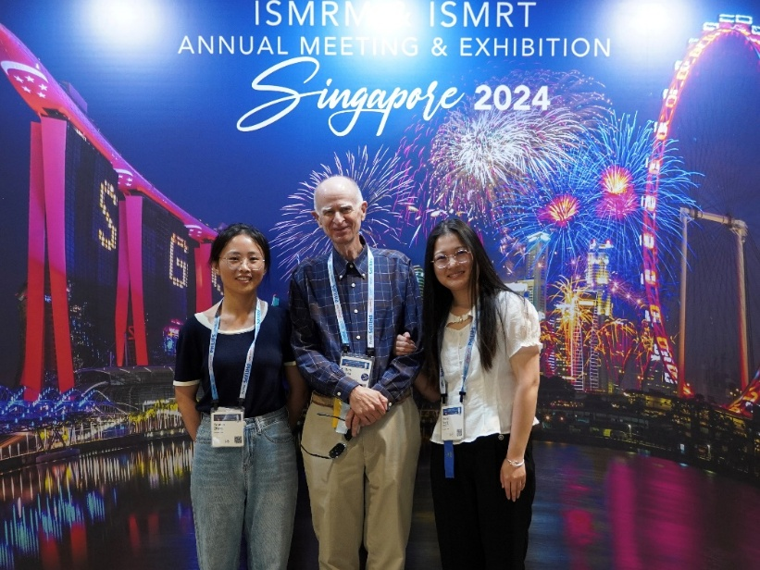

12. This last year I was awarded the Chang Jiang Scholarship, a 3-year award usually for Chinese people but on occasion for a foreigner. There are only 200 given out across China each year. I was honored to receive this award. Throughout the last 7 years, Wu Bo supported my efforts in Shanghai and all around China. He has made much of the travel and collaborations possible. This is, in large part, thanks to his constant support in carrying out those projects.
13. These days we have been developing a mnew software I call SPIRIT, (Signal Processing In Rapid Imaging Technology). Another software I developed years ago was CROWN (Constrained Reconstruction Of White Noise).
14. Funny, this morning this case took only 2 min to process a full brain STAGE acquisition, but last night it took 4 minutes. Why such a variation in processing speed. Did my laptop have a good sleep last night and wake up full of energy? I assume some other functions running in the background can slow the access to the processor.
15. Speaking of acronyms that I have coined over the years, MARSUPIAL, is perhaps the cutest of them all. MARSUPIAL = Motion Artifact Reduction …..

