A Practical Guide to Measuring Contrast-to-Noise Ratio in MRI
E. Mark Haacke, Ph.D.
Department of Radiology, Wayne State University, Detroit, Michigan, USA
Ruijin Hospital, Shanghai Jiao Tong University School of Medicine, Shanghai, China

Abstract
Contrast-to-noise ratio (CNR) is among the most frequently misreported quantities in the MRI literature, not because the underlying concept is difficult, but because the standard deviation in the denominator is routinely measured incorrectly. A naive region-of-interest (ROI) measurement of image noise is contaminated by structural variation across the ROI, by spatial non-uniformity introduced by parallel imaging reconstruction, and by distance-dependent coil sensitivity falloff — all of which inflate the apparent noise and depress the reported CNR. This paper presents a systematic framework for correctly measuring noise, contrast, and CNR in MRI images. We describe several CNR metrics such as using two repeated acquisitions or a single acquisition with three-echo data both of which yield a more reliable noise estimate than direct ROI measurement. We derive the scaling factors (√2 and √1.5, respectively) needed to recover the true noise standard deviation from each approach. We further show, using the variance sum law, why relative contrast is scale-invariant and therefore the preferred metric when comparing data across scanners, sites, or sessions with day-to-day signal scaling variability. Worked examples from clinical brain MRI data illustrate the magnitude of the error introduced by naive noise measurement, in one case showing a 53% overestimate of noise (and a correspondingly large underestimate of true CNR) when structural variation was not removed.

1. Introduction
Contrast and contrast-to-noise ratio (CNR) are reported in nearly every MRI methods paper that claims a new sequence, processing pipeline, or contrast mechanism that improves lesion conspicuity, tissue differentiation, or diagnostic confidence. Despite this ubiquity, the standard deviation term that appears in the denominator of CNR is frequently measured in a way that silently corrupts the result. The core difficulty is that a region of interest placed in nominally uniform tissue is rarely perfectly uniform: physiological structure, partial volume effects, and — increasingly, with the widespread adoption of parallel imaging — spatially varying reconstruction noise all introduce additional variance into the ROI that has nothing to do with the true thermal and electronic noise floor of the acquisition. The result is a measured standard deviation that is too large, a CNR that is reported as too small, and conclusions about diagnostic conspicuity that may be substantially understated.
This paper lays out, in a systematic way, how to measure noise correctly, which of several candidate contrast and CNR definitions is most appropriate for a given comparison, and how to validate that a noise estimate is trustworthy before using it. We begin with the four most commonly used contrast and CNR metrics and their relative merits and pitfalls. We then turn to the central practical problem — how to obtain an unbiased estimate of the true noise standard deviation — and present two complementary subtraction-based approaches: acquiring the same data twice and exploiting a three-echo acquisition in which the middle echo is predicted from the average of its neighbors. Each approach introduces a known scaling factor between the standard deviation of the subtracted (difference) image and the true single-image noise standard deviation, and we derive these factors explicitly using the variance sum law. We close with worked clinical examples that quantify the practical consequences of getting this wrong, and with a concise set of recommendations for reporting noise, contrast, and CNR.

2. Four Candidate Measures of Contrast and Contrast-to-Noise
Given two signal intensities S₁ and S₂ measured in two tissues or two conditions of interest, there are at least four distinct ways to quantify the difference between them, each with different strengths and different sensitivities to systematic error.
- Contrast: C = S₁ − S₂. This is the simplest measure, but it is dangerous to use in isolation if the imaging system has any scaling variability from session to session or scanner to scanner, since an arbitrary intensity rescaling will change C without any change in the underlying tissue contrast. If this metric is used, the recommended practice is to plot a histogram of the contrast values measured across the full study population; if the distribution is approximately Gaussian, the mean and standard deviation of this distribution can be reported with reasonable confidence.
- Contrast-to-noise ratio: CNR = (S₁ − S₂)/σ_{o}, where σ_{o} is the true noise standard deviation, assumed constant across the data sets being compared. This is the most physically meaningful metric, but its correct use depends entirely on obtaining an unbiased estimate of σ_{o} — the central challenge addressed in Section 3.
- Relative (normalized) contrast: C_{rel} = (S₁ − S₂)/S₂. As shown in Section 4, this quantity is invariant to any uniform rescaling of the signal intensities, which makes it the preferred metric for comparisons across sessions, sites, or scanners where day-to-day or system-to-system scaling drift is a concern.
- Alternate normalized contrast-to-noise: CNR_{rel-alt} = (S₁ − S₂)/σ_{S2}, where σ_{S2} is the standard deviation measured directly within the S₂ region. This is generally the least reliable of the four metrics, because σ_{S2} is corrupted by background structural signal variation in exactly the way described in Section 1, and this corruption can dominate the result, producing similar inflated CNR-like values across images almost independent of the true noise level.
The remainder of this paper is devoted to two practical questions that follow directly from these four definitions: how to measure σ_{o} correctly for use in CNR, and why C_{rel} is generally the more robust choice in the presence of systematic scaling differences between acquisitions.

3. The Central Problem: Measuring True Image Noise
To compute CNR correctly, an ROI must be drawn in a region that is genuinely uniform in the underlying tissue signal, since any spatial variability of the true signal within the ROI inflates the measured standard deviation and corrupts the noise estimate. In practice, this total measured standard deviation σₘ reflects contributions from both the true noise σₒ and any residual structural variation σₛ within the ROI, related approximately as:
σ²_{m} = σ²_{s} + σ²_{o}
Because perfectly uniform tissue regions are difficult to guarantee in practice — particularly in brain imaging, where white matter, gray matter, and partial volume boundaries are densely packed — the most reliable approach is not to measure σₒ directly from a single image, but to construct a subtracted (difference) image in which the true tissue signal cancels out entirely, leaving only noise.

3.1 The Repeated-Acquisition Method
The most direct subtraction approach is to acquire the same data set twice under identical conditions and subtract the two resulting images:
ΔS = S₁ − S_{1′}
Since the true tissue signal is identical in both acquisitions, it cancels exactly upon subtraction, leaving a difference image whose mean should be close to zero and whose standard deviation reflects only the combined noise of the two acquisitions. Using the variance sum law (formally derived in Section 4), if the two acquisitions have equal and independent noise variance σₒ², the variance of the difference is:
variance(ΔS) = variance(S₁) + variance(S_{1′}) = 2σ²_{o}
and, therefore, the standard deviation of the subtracted image is σ_{ΔS} = √2·σ_{o}. The true single-acquisition noise is recovered by dividing the measured difference-image standard deviation by √2:
σo = σΔS / √2
However, even this approach is not immune to scaling issues. That’s because some manufacturers scale each and every sequence to make it easy for the radiologists to view. For example, to guarantee the same scale factor on a Philips scanner you must use the lock function. On a Siemens scanner no such operation is required.

3.2 The Three-Echo Method
When only a single acquisition is available, repeating the scan is not always practical, but a closely related approach is available for multi-echo sequences acquired at evenly spaced echo times — for example, TE values of 7.5, 15, and 22.5 ms. In this case, the middle echo can be predicted from the average of its two neighbors, and the prediction error provides the noise estimate:
ΔS = S(TE₂) − avg[S(TE₁), S(TE₃)]
provided the underlying signal decay is sufficiently linear across the three echoes that the true signal at TE₂ is well approximated by the average of the signals at TE₁ and TE₃ — in which case ΔS should again be close to zero on average, just as in the repeated-acquisition method. Writing this explicitly as a weighted combination of three independent noise sources:
ΔS = ¹⁄₂[S(TE₁) + S(TE₃)] − S(TE₂)
the variance of this combination, again applying the variance sum law to each independently weighted term, is:
variance(ΔS) = (¹⁄₄ + ¹⁄₄ + 1)σ²_{o} = 1.5σ²_{o}
so that σ_{ΔS} = √1.5·σ_{o}, and the true noise is recovered as:
σ_{o} = σ_{ΔS} / √1.5
An important and useful diagnostic feature of both subtraction methods is that the boundaries between tissue types disappear entirely in the resulting difference image when the noise model is correct — since the true signal cancels exactly regardless of which tissue it came from, any residual visible structure in the difference image is itself diagnostic evidence of imperfect cancellation, scan-to-scan motion, or a non-uniform scaling difference between the two source images that should be investigated before the noise estimate is trusted. This won’t be exactly the case for the three echo scenario because there are differences in T2* for each tissue type, but the shorter the echo time interval the less obvious such differences will be.

4. The Variance Sum Law and Why It Underlies Noise Measurement
The scaling factors of √2 and √1.5 derived above both follow from the variance sum law, which states that for two independent random variables X and Y, the variance of their difference Z = X − Y is the sum of their individual variances:
variance(Z) = variance(X) + variance(Y)
If X and Y have equal variance σ_{o}², this reduces to variance(Z) = 2σ_{o}², and, therefore, the standard deviation of Z is σ_{Z} ≈ √2·σ_{o}, which can be inverted to give σ_{o} = σ_{Z}/√2 — precisely the relationship used in the repeated-acquisition noise estimate above. The same law, applied to the three unequally weighted terms of the three-echo prediction error, yields the √1.5 scaling factor used in Section 3.2. It is worth emphasizing that the variance sum law applies strictly to the variance, not the standard deviation, of the contributing terms — a point of frequent confusion that leads to incorrect noise estimates when variances and standard deviations are added interchangeably.
It is also worth noting explicitly that the act of measuring noise is itself subject to noise: any single ROI-based estimate of σₒ, however carefully obtained, carries its own sampling uncertainty. A more robust practice, particularly in papers intended to establish a noise or CNR benchmark for a given sequence and coil combination, is to measure the noise in 10 to 30 representative cases, construct a histogram of the resulting standard deviation estimates, and use the mean of that distribution as a single representative noise value for the full study population — rather than re-measuring noise independently, and with correspondingly greater individual uncertainty, for every subject. That is, for CNR measurements, only one standard error or noise should be used throughout a given set of data all collected the same way.

5. Scale Invariance of Relative Contrast
A second, independent reason to prefer relative contrast over absolute contrast in multi-session or multi-site comparisons is its invariance to uniform signal rescaling. Suppose one subject is correctly characterized by signal values (S₁, S₂), while a second subject — due to a difference in coil loading, receiver gain, or any other scanner-level scaling factor — produces signal values that are uniformly scaled by some factor a, i.e., (S₁′, S₂′) = (aS₁, aS₂). The absolute contrast for the second subject, C′ = aS₁ − aS₂ = a(S₁ − S₂), will appear to scale directly with “a” — a purely artifactual change with no relationship to true tissue contrast. Relative contrast, by comparison, is unaffected:
C_{rel} = (S_{1′} − S_{2′})/S_{2′} = (aS₁ − aS₂)/(aS₂) = (S₁ − S₂)/S₂
the scaling factor “a” cancels exactly, leaving C_{rel} unchanged regardless of the value of “a”. This property — referred to here as scale invariance — makes relative contrast the preferred metric whenever day-to-day or system-to-system scaling variability cannot be ruled out, which in practice is nearly always the case in multi-session clinical studies.
This same scale-invariance argument explains why the alternate normalized CNR metric, CNRᵣₑₗ₋ₐₗₜ = (S₁ − S₂)/σₛ₂, is the least desirable of the four metrics introduced in Section 2. If σₛ₂ is, as is often approximately true, simply a constant fraction of S₂ — that is, σₛ₂ ≈ S₂/b for some constant b — then this metric reduces algebraically to a constant multiple of relative contrast:
CNR_{rel-alt} = (S₁ − S₂)/σ_{S2} = b(S₁ − S₂)/S₂ = b·C_{rel}
Since CNR_{rel-alt} is, in this idealized case, simply a rescaled version of the more easily and more robustly measured C_{rel}, and since σ_{S2} is, in practice, difficult to measure accurately and highly sensitive to background structural variation when it is present, the more direct and robust choice, in nearly all circumstances, is to report C_{rel} rather than attempting to measure CNR_{rel-alt} directly.

6. The Rose Criterion and Interpreting CNR Values
Once a reliable estimate of σₒ has been obtained, the resulting CNR value can be interpreted against a long-established visibility threshold known as the Rose criterion, which holds that a contrast difference becomes reliably and consistently visible to a human observer, or reliably detectable by an automated algorithm, only once CNR exceeds approximately 3:1 to 5:1. CNR values below this threshold, even if nominally greater than zero, generally do not correspond to a difference that can be confidently identified against the background noise floor of the image. However, visibility, V, is defined as:
V = CNR*sqrt(N)
where N is the number of points in the region of interest. This means that the human brain-eye system can recognize the presence of and object of 100 pixels in size even if the CNR is only 0.5, for example.
This threshold provides a useful internal consistency check on a noise measurement. If a calculated CNR value comes out unexpectedly low — for example, 1:1 or 0.5:1, for a contrast that is clearly and consistently visible on visual inspection of the images — this is a strong indication that the noise estimate σₒ has been inflated by uncorrected structural variation in the ROI, rather than an indication that the true contrast-to-noise performance of the sequence is genuinely poor. Conversely, a well-measured CNR for a clearly visible contrast (for example, gray-white matter differentiation in a T1-weighted sequence) should generally be comfortably above 5:1. Reported CNR values in this range, obtained using the subtraction-based noise estimation methods described in Section 3, can be regarded as trustworthy.
A representative numerical illustration makes this concrete. Consider a measurement in which the background signal level is 210 units with a noise standard deviation of approximately 7 units, giving an SNR of roughly 30:1 — by most conventional standards, an excellent signal-to-noise ratio. If the contrast between white matter and gray matter in this same image is only 35 units, then the resulting CNR is only 5:1, a substantially less generous margin than the SNR alone would suggest. This example underscores that a high SNR does not guarantee a high CNR for any particular tissue contrast of clinical interest, and that the two quantities must be evaluated and reported separately.

7. Worked Clinical Examples
The practical consequences of correct versus naive noise measurement are best illustrated with real clinical brain MRI examples. In one representative case, (see Figure 1), two repeated acquisitions of the same brain volume were subtracted to estimate noise. At the edge of the brain, where parallel imaging reconstruction artifacts are typically smaller and coil sensitivity is highest, the measured standard deviation in the difference image was 8.6 units; in the middle of the brain, where reconstruction noise amplification from parallel imaging and increased distance from the surface coil elements both degrade SNR, the measured standard deviation was 18.8 units — roughly double the edge value. In both regions, the mean of the difference image was close to zero, as expected when the true tissue signal cancels correctly. Applying the √2 correction described in Section 3.1, the true noise standard deviation at the edge of the brain is 8.6/√2 ≈ 6.1 units, and in the middle of the brain is 18.8/√2 ≈ 13.3 units.
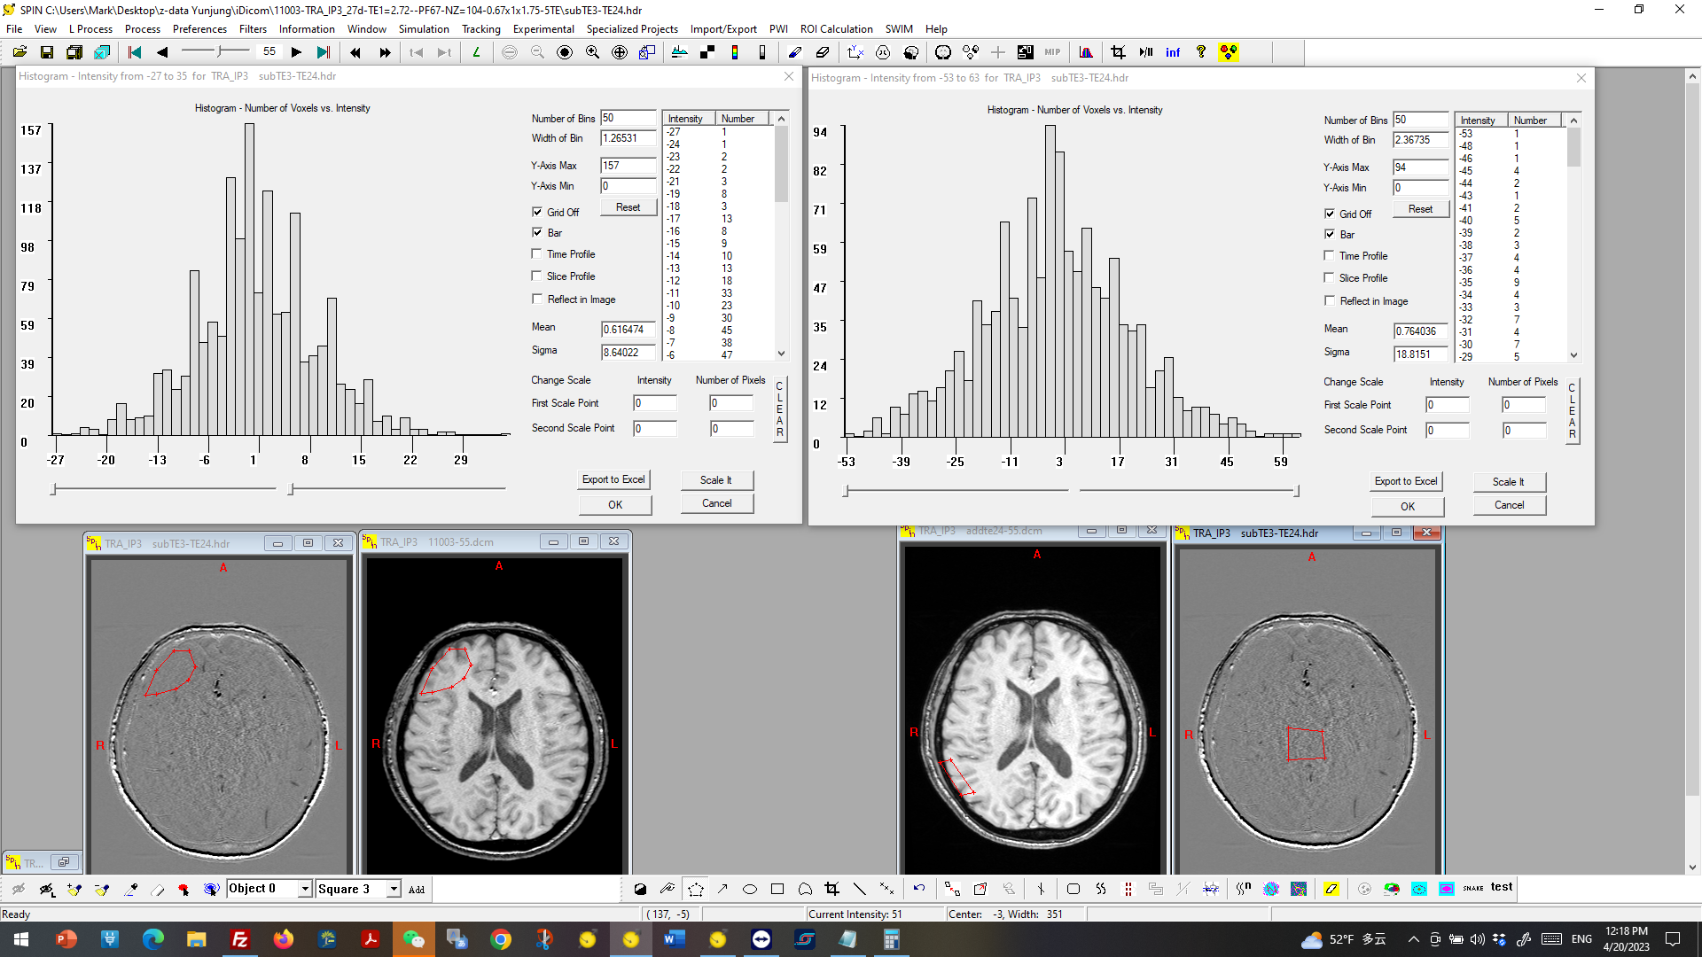

Figure 1: Noise on the left at the edge of the brain is 8.6 units and noise for the middle of the brain is 18.8 units roughly double that at the edge (due to parallel imaging and distance from the coils). As expected, the average is close to zero! But these are not σ_{o} rather they represent sqrt(2)σ_{o} . The true estimate of noise on the left at the edge of the brain is 8.6/sqrt(2) = 6.1 units. The true estimate of the noise for the middle of the brain is 18.8/sqrt(2) = 13.3.

A second example used the three-echo subtraction approach described in Section 3.2. In this case, the naively measured ROI standard deviation — obtained by direct measurement within a single image, without any subtraction-based correction — was 478 units. Using the three-echo difference-image approach instead, the measured standard deviation of the prediction-error image was 383 units, which, following the √1.5 correction, gives a true noise estimate of 383/√1.5 ≈ 312 units. The naive estimate of 478 units is approximately 53% larger than the correctly derived value of 312 units — a substantial overestimate of noise that would correspondingly understate the true CNR by a similar margin if used in a CNR calculation.
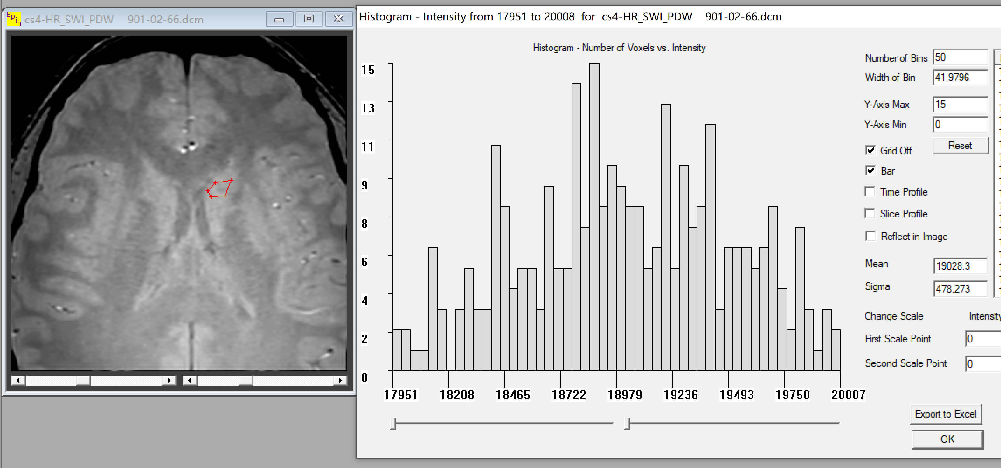
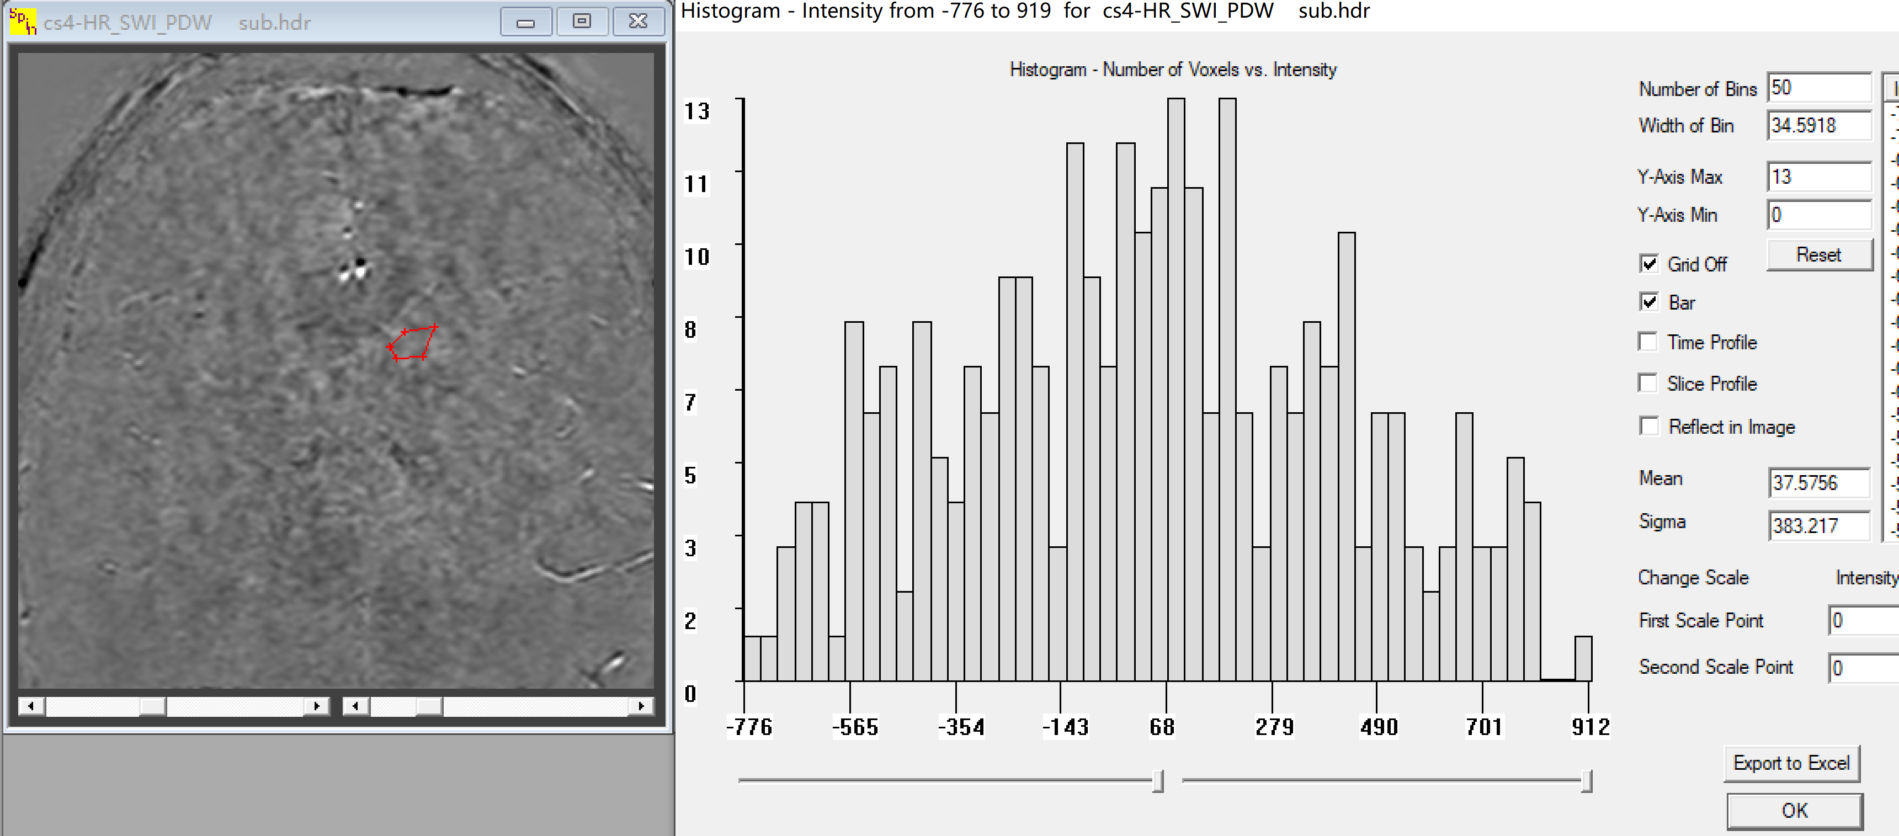
Figure 2: The upper figure shows the magnitude image and a region of interest in the caudate nucleus. The mean is 19028.3 and the standard deviation is 478.3. However, in the subtracted image, the mean is 37.6 (close to zero relative to 19028.3) and the standard deviation is only 383.2. Note there are no boundaries in this subtraction. Now 383.2/sqrt(2) is 271.0 much less than 478.3.
Now the contrast between white matter and gray matter for this example was 3700. Using the naive noise value, the apparent CNR for a given tissue contrast was calculated as approximately 10:1; using the corrected noise value, the true CNR was 14.6:1 — a difference large enough to materially affect the conclusions of a study comparing two sequences or reconstruction methods against the Rose criterion threshold described in Section 6. In another example, with a naive standard deviation of 412 units, the corrected value was only 132 units. That changes the CNR from 9:1 to 28:1.

8. Recommendations for Reporting Noise, Contrast, and CNR
Based on the foregoing analysis, the following practices are recommended when measuring and reporting noise, contrast, and CNR in MRI studies.
- Never estimate the noise standard deviation directly from a single ROI placed in a single image unless the uniformity of that ROI has been explicitly verified, for example by plotting the signal profile across the ROI and confirming that it is flat.
- Prefer a subtraction-based noise estimate wherever possible — either from two repeated acquisitions of the same data (apply the √2 correction) or, for sequences with three or more echoes, from the prediction-error image formed by subtracting the second echo from the average of its two neighbors (apply the √1.5 correction).
- Verify that the resulting difference image shows no or very small residual visible boundary structure between tissue types; visible structure indicates incomplete signal cancellation and an unreliable noise estimate.
- When a single representative noise value is needed for a full study population, measure noise in a subset of 10 to 30 representative cases, construct a histogram of the resulting estimates, and use the mean of that distribution rather than re-measuring noise independently for every subject.
- Report relative contrast (C_{rel}) in preference to absolute contrast (C) whenever comparisons are made across sessions, sites, or scanners where day-to-day or system-to-system signal scaling cannot be ruled out, since C_{rel} is scale-invariant and absolute contrast is not.
- Avoid the alternate normalized CNR metric (CNR_{rel-alt}) except in carefully controlled circumstances, since the structural standard deviation term in its denominator is both difficult to measure accurately and prone to dominating the result in the presence of any background signal variation.
- Use the Rose criterion (CNR of approximately 3:1 to 5:1) as an internal consistency check: an unexpectedly low CNR for a contrast that is clearly visible on direct inspection should prompt re-examination of the noise estimation procedure rather than being reported uncritically.

9. Conclusion
Correct measurement of image noise is the single most consequential and most frequently overlooked step in computing a trustworthy contrast-to-noise ratio. A region-of-interest standard deviation measured directly from a single image is, except in unusually uniform tissue regions, contaminated by structural variation, parallel imaging reconstruction artifacts, and coil-distance-dependent sensitivity falloff, all of which inflate the apparent noise and depress the reported CNR — in the clinical examples presented here, by as much as 50% or more. Subtraction-based noise estimation, whether from two repeated acquisitions or from a three-echo prediction-error image, together with the corresponding √2 or √1.5 correction derived from the variance sum law, provides a reliable and easily validated alternative that should be adopted as standard practice. Relative contrast, owing to its scale invariance under uniform signal rescaling, should likewise be preferred over absolute contrast whenever comparisons span multiple sessions, sites, or scanner systems. Adopting these practices consistently will improve the reliability and comparability of contrast and CNR values reported across the MRI literature and will help ensure that claims of improved lesion conspicuity or tissue differentiation are grounded in correctly measured, rather than artifactually inflated or deflated, noise estimates.

